HFSC Amputee Connections Group

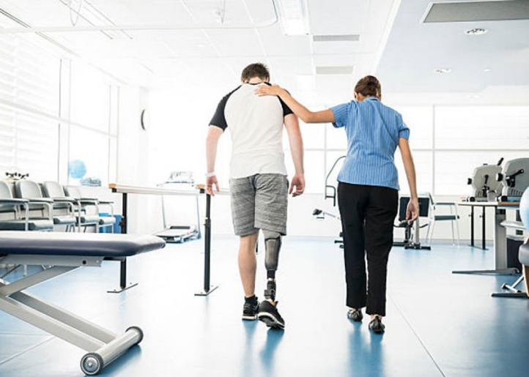
Meets the 2nd Wednesday of the month at 2:00 pm
at the Hospital for Special Care- 2150 Corbin Ave.

Join in person: NEW Location Library
Join by zoom: Scan the QR Code Below



Email: MLawlor@hfsc.org for details

