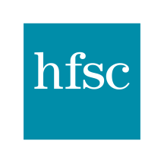
Hospital for Special Care
2150 Corbin Ave
New Britain, CT 06053
Summary of Financial Assistance Policy

If you need assistance paying the bill for services provided at Hospital for Special Care, you may apply for the hospital’s Financial Assistance Program. Eligibility for the program is based on income levels, available payment resources (such as insurance or Medicaid) and family size. You must submit this information with your application and meet the eligibility criteria described in the policy.
The Financial Assistance Program applies ONLY to services provided by our employees at our inpatient locations and outpatient clinics, and may not cover bills from independent physicians or other specialty providers that provide services at our locations. Patients eligible for financial assistance will not be charged more than the amount generally billed to patients with insurance for medically necessary care. Hospital for Special Care will respond to each application in writing. If your application is denied, you can re-apply at any time.
Where to Find Information
To get more information and a copy of the application forms, call an HSC Patient Account Representative (phone numbers are listed below), or speak with the Admissions office or any Registration Representative in our Outpatient clinics at 2150 Corbin Avenue.
Any of these HSC staff members can help you with the application process over the phone, and can mail you a paper copy of the policy and application forms.
You can also visit our website at http://hfsc.org to read more about the Financial Assistance Program and to download a Financial Assistance Program application.
Assistance needed?
For assistance or additional information on your application call Hospital for Special Care’s Patient Financial Services Department at 860-827-4900.
Representatives are available Monday – Friday from 8:00am to 4:30pm.

